**Project Proposal of Programming**

**Fundamentals Project Title**

“**LOG-IN & SIGN-UP PROCESS WITH “SQL**

**DATABASE” USING OBJECT ORIENTED**

**PROGRAMMING (OOP)**

**FUNDAMENTAL”**

|  |  |  |
| --- | --- | --- |
| **Group Members**  **Seat Numbers:**  **Section:** | Bilal Ahmed , Abdul Munim  ------------------,----------------  B |  |

**Project Objective:**

• In our project we are making sign-up and log-in process with SQL Database using Object Oriented Programming (OOP) Fundamentals which can be used in different platforms, websites, computer application, mobile apps and firms for data consumption of users that are using their website.

**Project Description:**

• In our project we are making sign-up and log-in process with SQL Database using Object Oriented Programming (OOP) Fundamentals the libraries which used in this project are: Tkinter as tk, Tkinter as ttk, tkinter for OOP (tk.Tk), sqlite3 for SQL Database, PILLOW (PIL) for image input.

**Project Tool and IDE:**

* You can run it on any Python related IDE like (Visual Studio, Pycharm, Python IDLE) (Python 3).

**How It Works:**

1. Firstly when you run the so a window appears like this: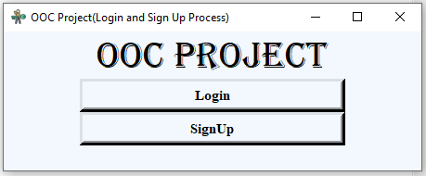

Here you can see a title “OOC (Login and Sign Up Process)”, and a Label “OOC Project” and below them two buttons are planted named “Logon” and “SignUp”.

1. Firstly you have to press “SignUp” button so the window of Sign Up will appear like this: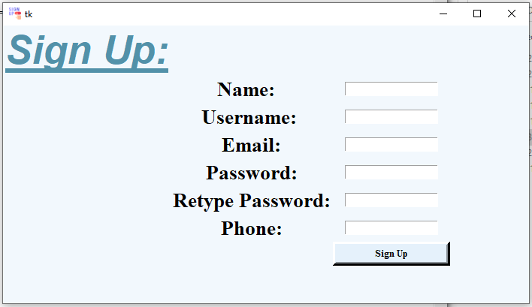

* In this you can see a Label like heading “Sign Up” and multiple entries: Name, Username , Email, Password, Retype Password, and Phone which are essential in any sign up page.
* So if you fulfill all the entries and press the button at the bottom so a showinfo window will appear like this:

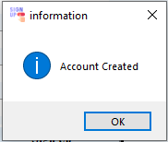

Which shows that your account is now created and on the SQL database and now you can login through it.

1. Now you have to run the program again for login using the info. You had sign up so you have to run the program and on the main window press the login button so Login window will appear like this:

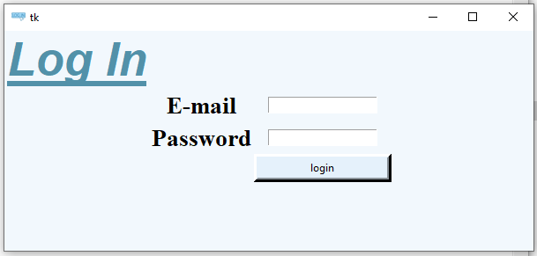

* In this only correct info will provide you login, wrong info. throw an error like this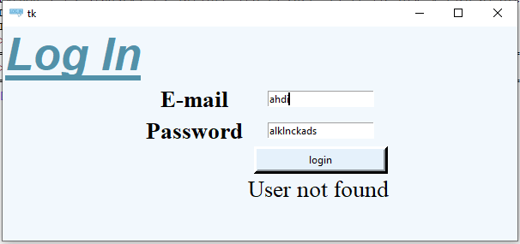
* And if you put correct information that you had provided at the time of Sign Up so you will login to your account and a message will appear on the screen like this: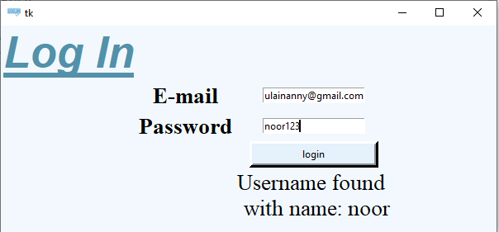
* Which prove that your information is correct and according to your database entry.

**Flow Map:**



**Contributions:**

|  |  |
| --- | --- |
| **Project searching**:  **Data gathering:**  **Programming:**  **Code Modification:**  **Technical Writing and Maintaining Proposal:**  **Report:** | Abdul Munim,  Bilal Ahmed  Bilal Ahmed  Abdul Munim  Bilal Ahmed, Abdul Munim  Bilal Ahmed |

**Submitted to: Sir Sadiq**

**Submitted on: 20/09/2022**